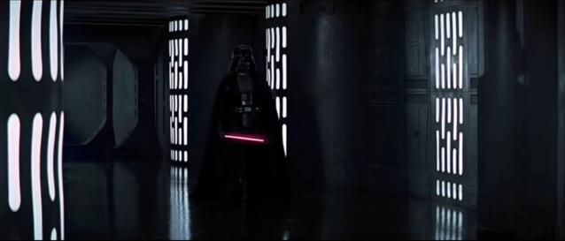

**VADER: I've been waiting for you, Obi-Wan. We meet again, at last. The circle is now complete.**

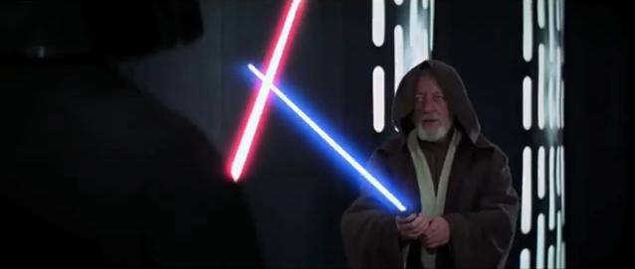

**BEN: Only a master of evil, Darth.**

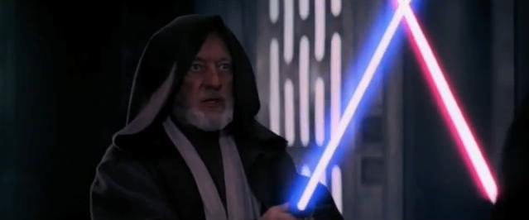

**BEN: You can't win, Darth. If you strike me down, I shall become more powerful than you can possibly imagine.**

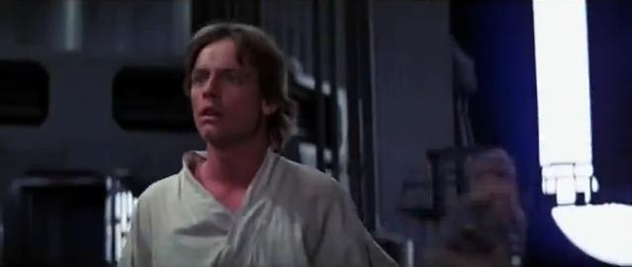

**LUKE: Look!**

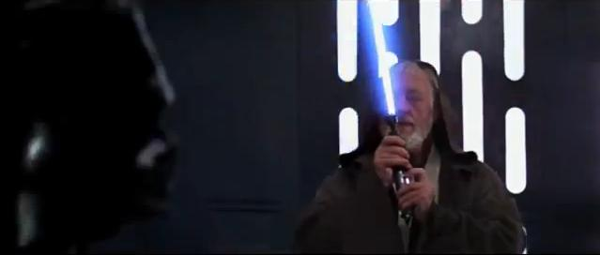

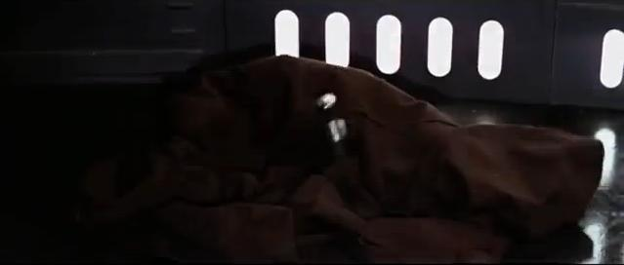

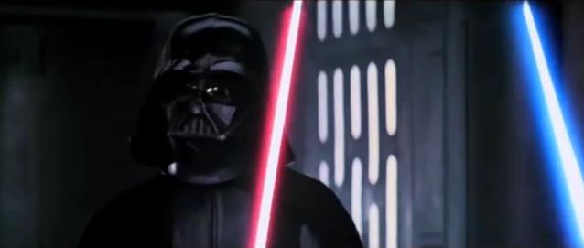

**VADER: When I left you, I was but the learner; now I am the master.**

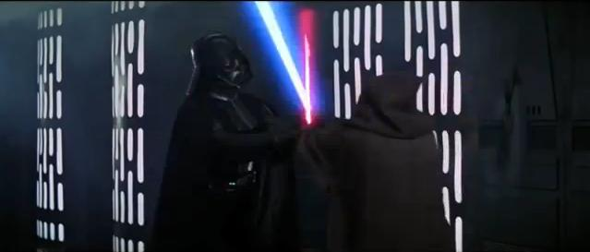

**VADER: Your powers are weak, old man.**

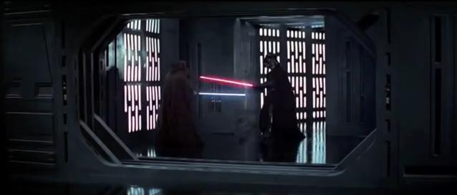

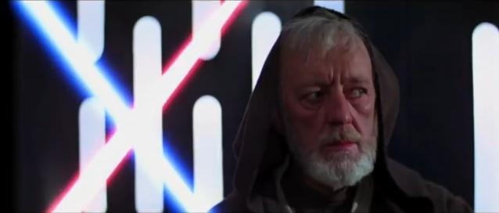

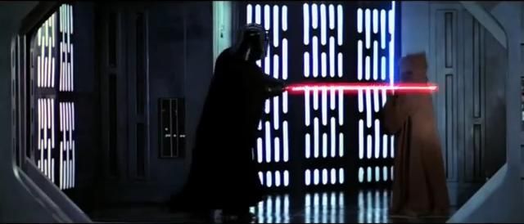

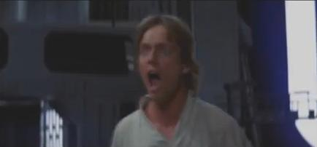

**LUKE: No!**

**Script**

**INTERIOR: DEATH STAR**

Ben hurries along one of the tunnels leading to the hangar where the pirate ship waits. Just before he reaches the hangar, Darth Vader steps into view at the end of the tunnel, not ten feet away. Vader lights his saber. Ben also ignites his and steps slowly forward.

**VADER: I've been waiting for you, Obi-Wan. We meet again, at last. The circle is now complete.**

Ben Kenobi moves with elegant ease into a classical offensive position. The fearsome Dark Knight takes a defensive stance.

**VADER: When I left you, I was but the learner; now I am the master.**

**BEN: Only a master of evil, Darth.**

The two Galactic warriors stand perfectly still for a few moments, sizing each other up and waiting for the right moment. Ben seems to be under increasing pressure and strain, as if an invisible weight were being placed upon him. He shakes his head and, blinking, tries to clear his eyes. Ben makes a sudden lunge at the huge warrior but is checked by a lightning movement of The Sith. A masterful slash stroke by Vader is blocked by the old Jedi. Another of the Jedi's blows is blocked, then countered. Ben moves around the Dark Lord and starts backing into the massive starship hangar. The two powerful warriors stand motionless for a few moments with laser swords locked in mid-air, creating a low buzzing sound.

**VADER: Your powers are weak, old man.**

**BEN: You can't win, Darth. If you strike me down, I shall become more powerful than you can possibly imagine.**

Vader and Ben Kenobi continue their powerful duel. As they hit their light sabres together, lightning flashes on impact. Troopers look on in interest as the old Jedi and Dark Lord of the Sith fight. Suddenly Luke spots the battle from his group's vantage point.

**LUKE: Look!**

Luke, Leia, Han, and Chewie look up and see Ben and Vader emerging from the hallways on the far side of the docking bay. Solo, Chewie, Luke, and Leia tensely watch the duel. The troops rush toward the battling knights.

**HAN: Now's our chance! Go!**

They start for the Millennium Falcon. Ben sees the troops charging toward him and realizes that he is trapped. Vader takes advantage of Ben's momentary distraction and brings his mighty light sabre down on the old man. Ben manages to deflect the blow and swiftly turns around. The old Jedi Knight looks over his shoulder at Luke, lifts his sword from Vader's then watches his opponent with a serene look on his face. Vader brings his sword down, cutting old Ben in half. Ben's cloak falls to the floor in two parts, but Ben is not in it.

Vader is puzzled at Ben's disappearance and pokes at the empty cloak. As the guards are distracted, the adventurers and the robots reach the star ship. Luke sees Ben cut in two and starts for him. Aghast, he yells out.

**LUKE: No!**

**Storyboard**

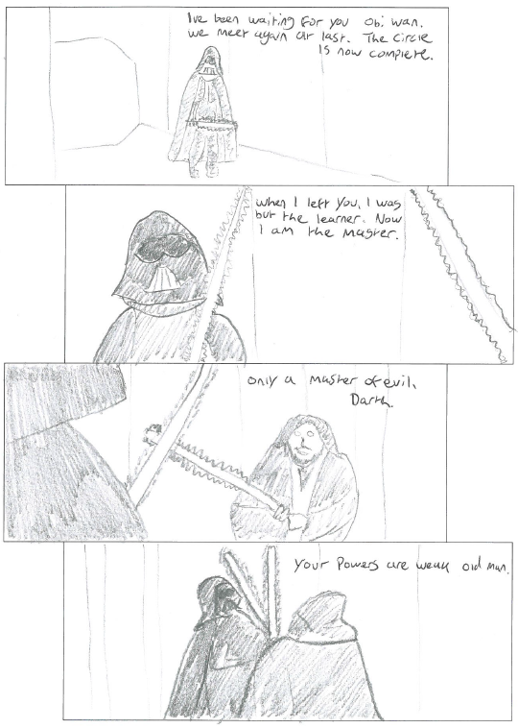

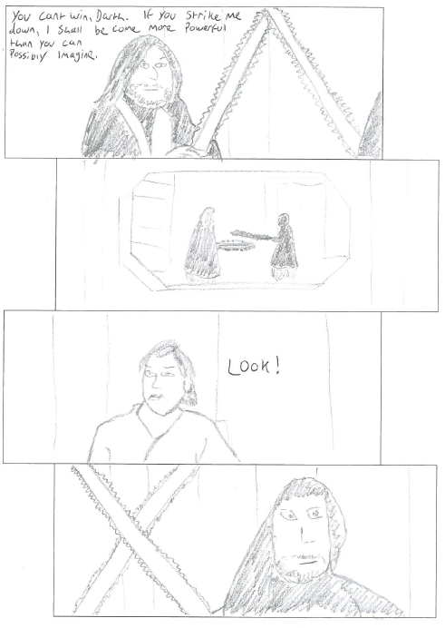

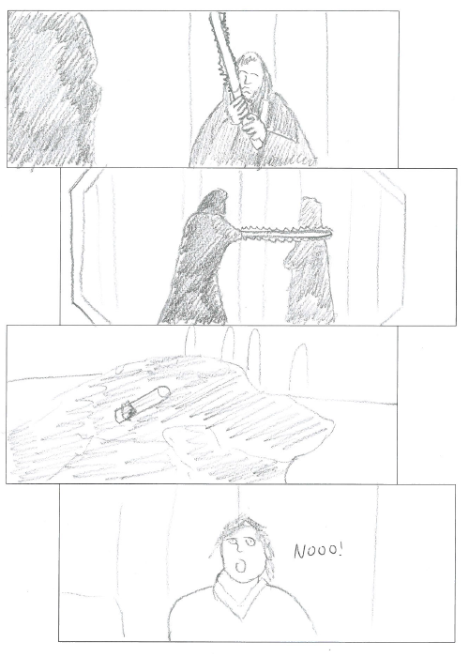

**Unedited Images**

For the background of the comic strip I decided to use pictures of the pub I work in. These are the unedited images that I will use to create the comic.

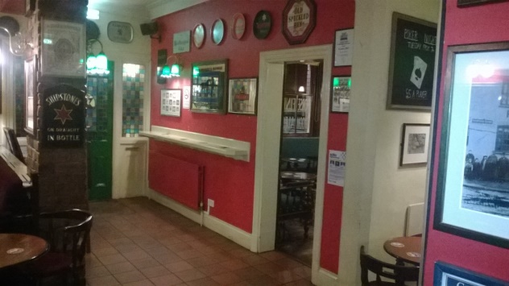 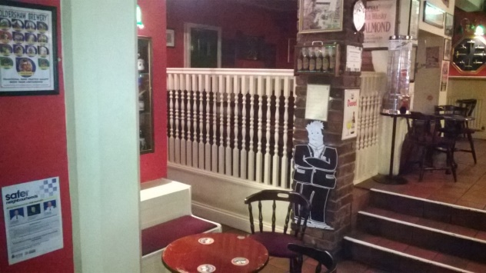

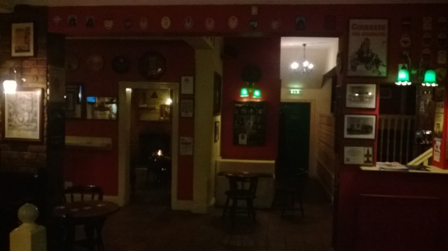 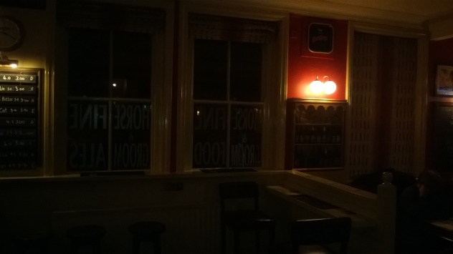

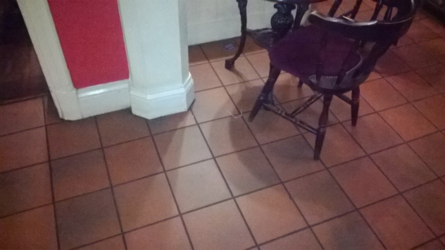

For the characters in the comic strip I decided to get a few of the regulars to pose and re-enact the scene from the film. Here are the unedited images.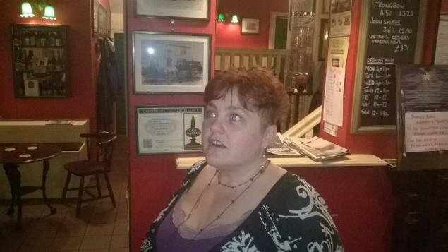 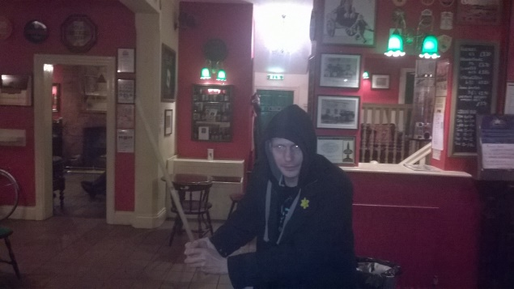 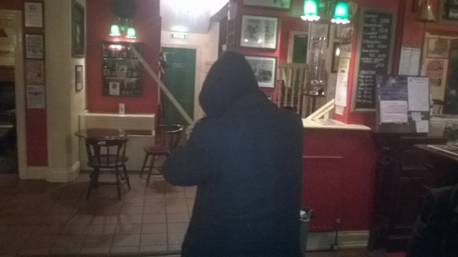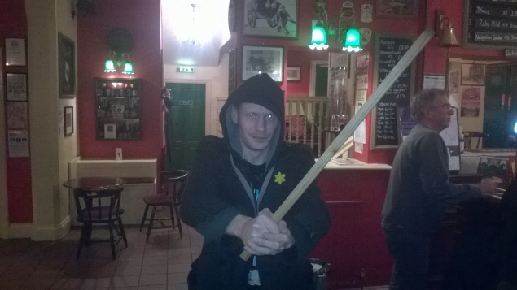 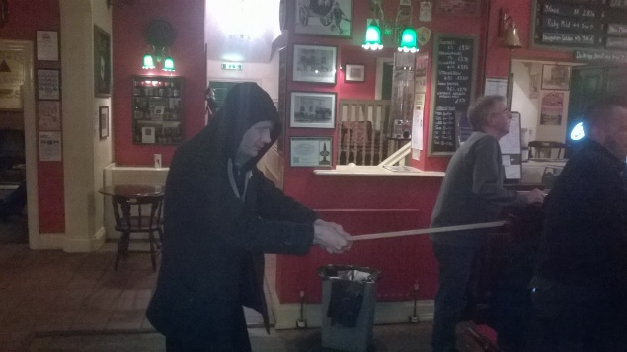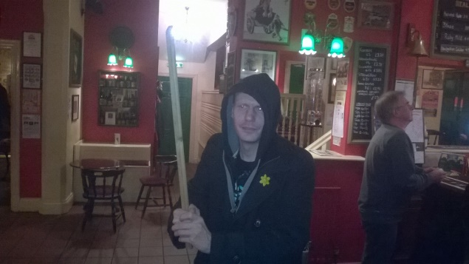 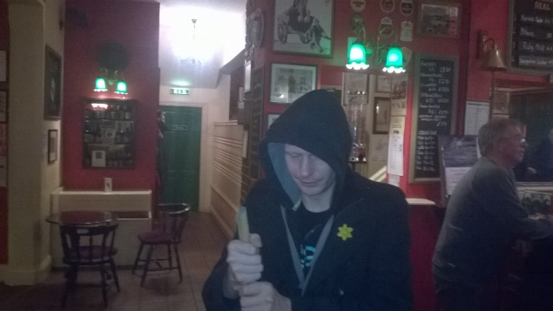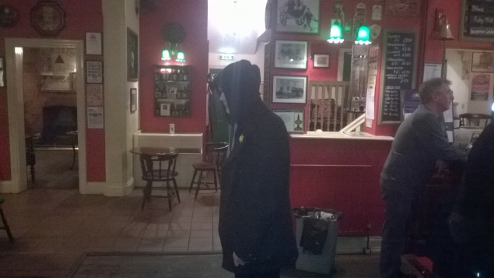 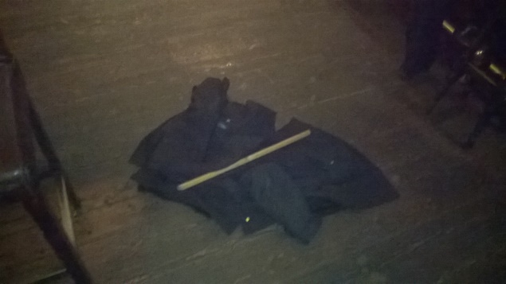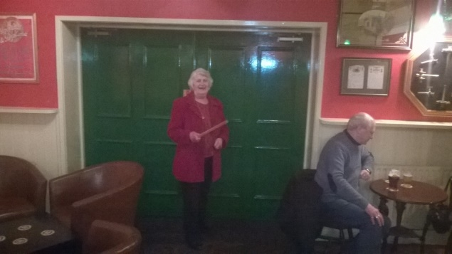 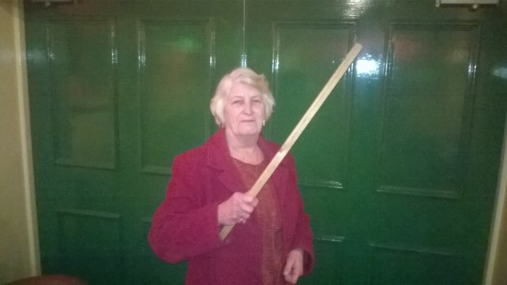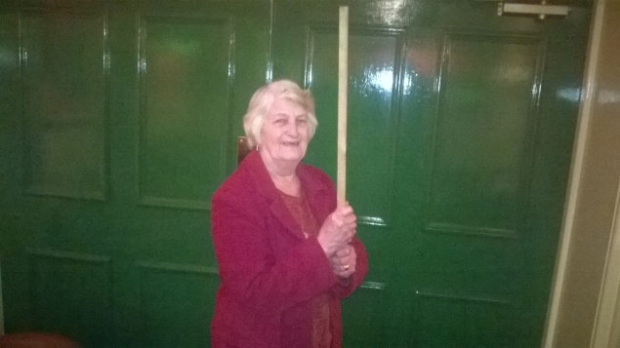 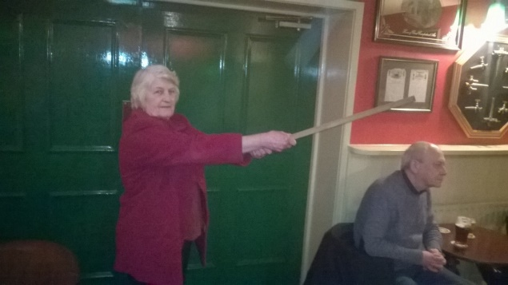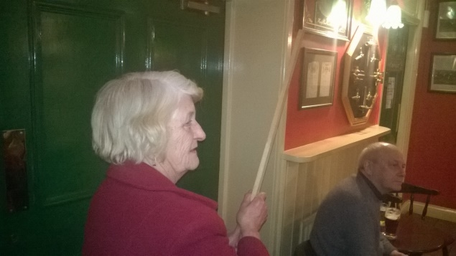

**Creation Process**

The first step in the creation process was to decide what parts of the background images I wanted to use for each frame. I then made the images greyscale to both try and match colours and provide a nice background effect.

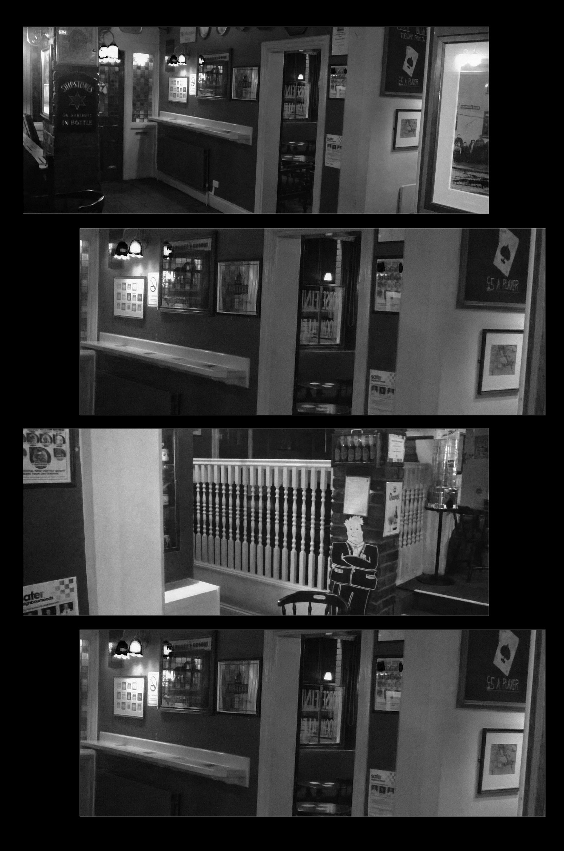

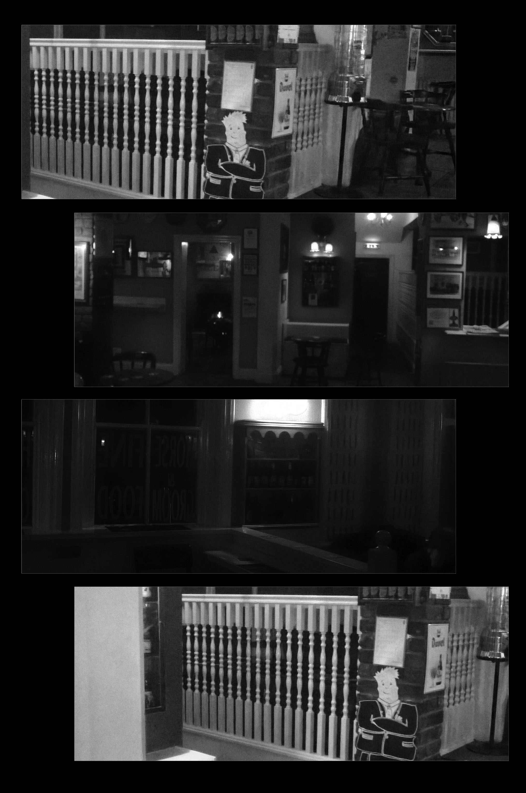

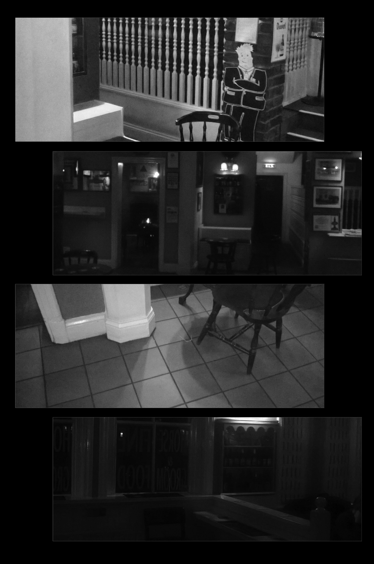

Then I started adding characters to the comic strip.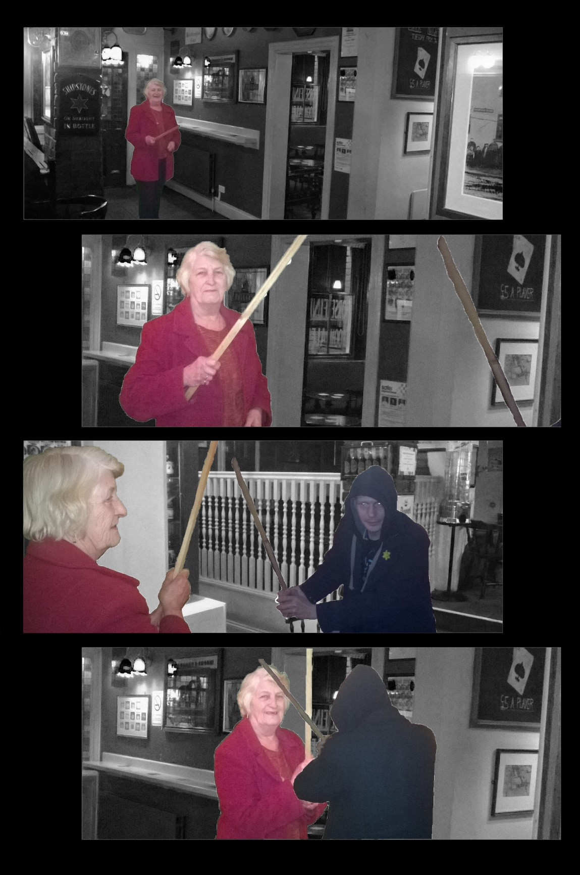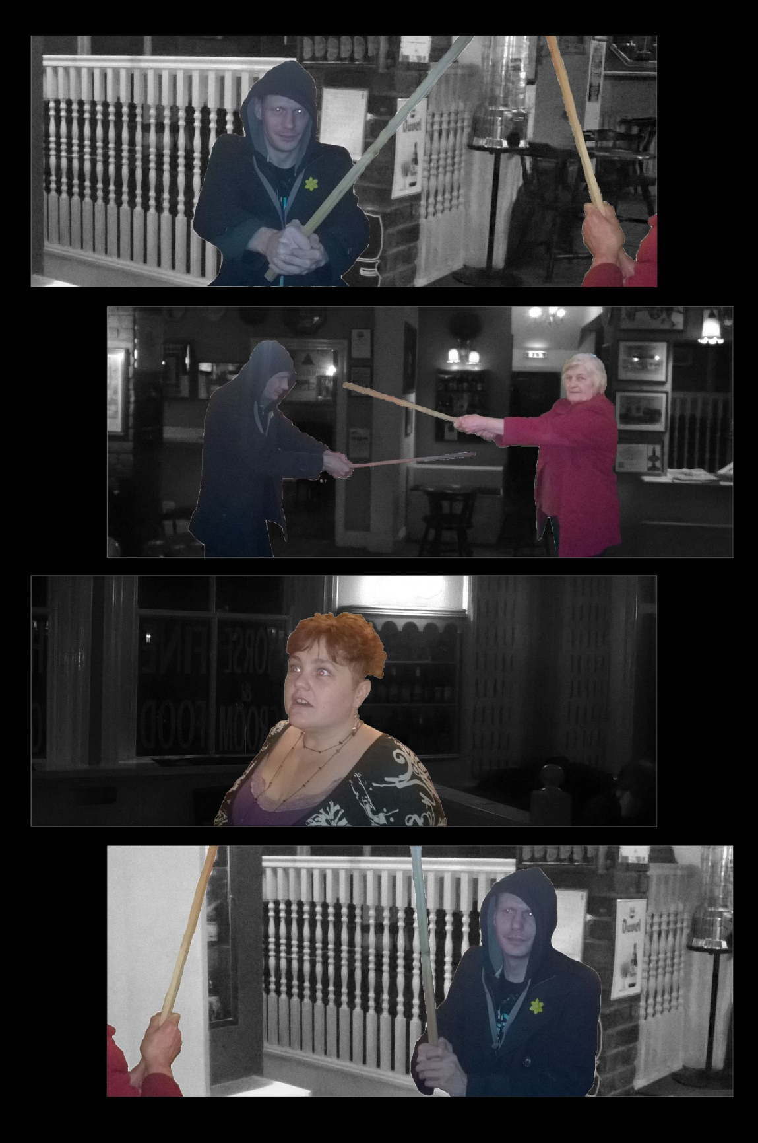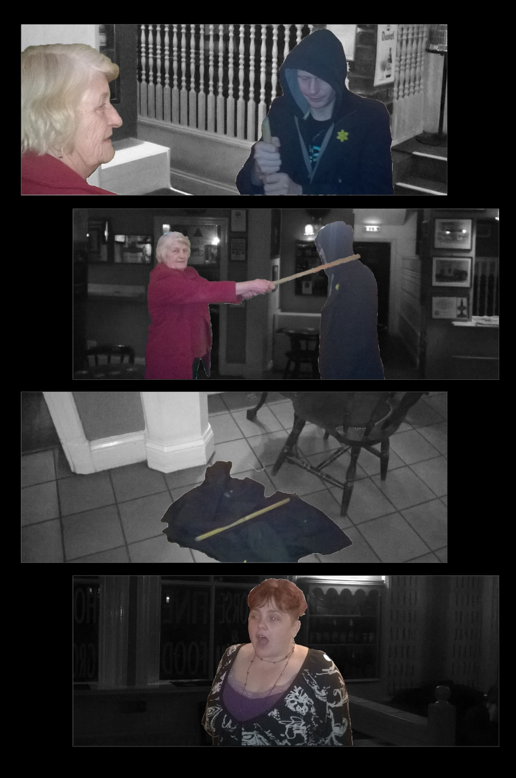

Finally I adjusted the colours, added some effects and added the text for a finished product.